Mateo A.Sierra

Project: Advantages and disadvantages of eating Unhealthy food.

1-Look at these statements: do you agree?  Do you disagree?

What can we add about playing sports?

Various scientific studies prove the enormous influence of diet on our health. 1 Poor eating habits, tobacco, alcohol consumption2 and lack of exercise cause in many people - especially from the sixties - the so-called diseases of civilization3, which are preventable. -Added to this is the abundance that surrounds us.

 2- Find information about the advantages of eating healthy food and disadvantages of eating unhealthy food.

Food today is a topic that is fashionable, many wonder, what is food. After they begin to investigate everything related to it, they begin to understand why.

If we see it from the point of view as a concept. We can say that food is a process by which living beings consume different types of food.

To obtain from them the necessary nutrients to survive and perform all the activities on a day-to-day basis.

We can also find words related to the topic of food. When we are looking for what is food.

And words appear to us like nutrition, food, nutrients are words that have to do with the term of food but they are not synonymous, therefore, they do not mean the same thing.

For example, a concept that is nutrition theoretically, we can say that it is a process by which, after feeding.

The body looks for nutrients in the food consumed. To transform them into energy to survive and subsist, on the other hand, when we seek what is food.It refers to the process of consuming food that will later provide the body with nutrients.

Balanced or healthy diet:

It is the benefit of a food from each food group to which it belongs and is consumed in portions according to the weight, height, and sex of each individual.

These food groups that we are talking about are divided into 5 categories such as carbohydrates, proteins, dairy products, fruits and vegetables and at the end we have fats and sugar.

Consuming foods that allow you to have a healthy and healthy diet brings many benefits for the human being within them we can highlight:

minimal chance of developing diseases

cholesterol control

lowers the risk of heart problems

lowers blood pressure

improves the immune system

among others.

However, on the contrary, we do not consume a balanced and healthy diet that indicates the concept of what food is. We are going to have the cons or disadvantages of an unhealthy diet.

This can trigger a series of eating disorders that can cause damage to health. In the development of an ordinary life and often becoming mortal.

3)Make a presentation on the information you found to present at the science fair. ( poster or you can use technological tools)

The rise in childhood obesity with junk food consumption. Weight gained during youth often persists into adulthood, and it places adults at risk for medical conditions like diabetes.

Unhealthy eating also has a surprising effect on mental health. For example, there is a relationship between junk food and violent behavior by wich kids eating junk foods suffer from such problems. 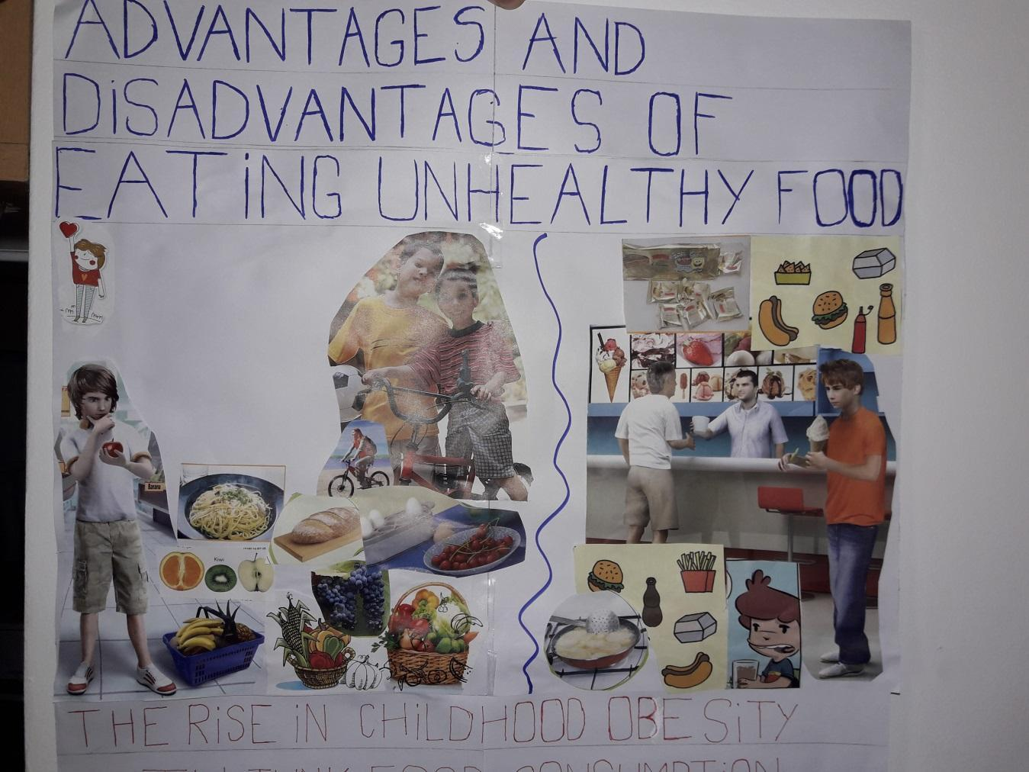

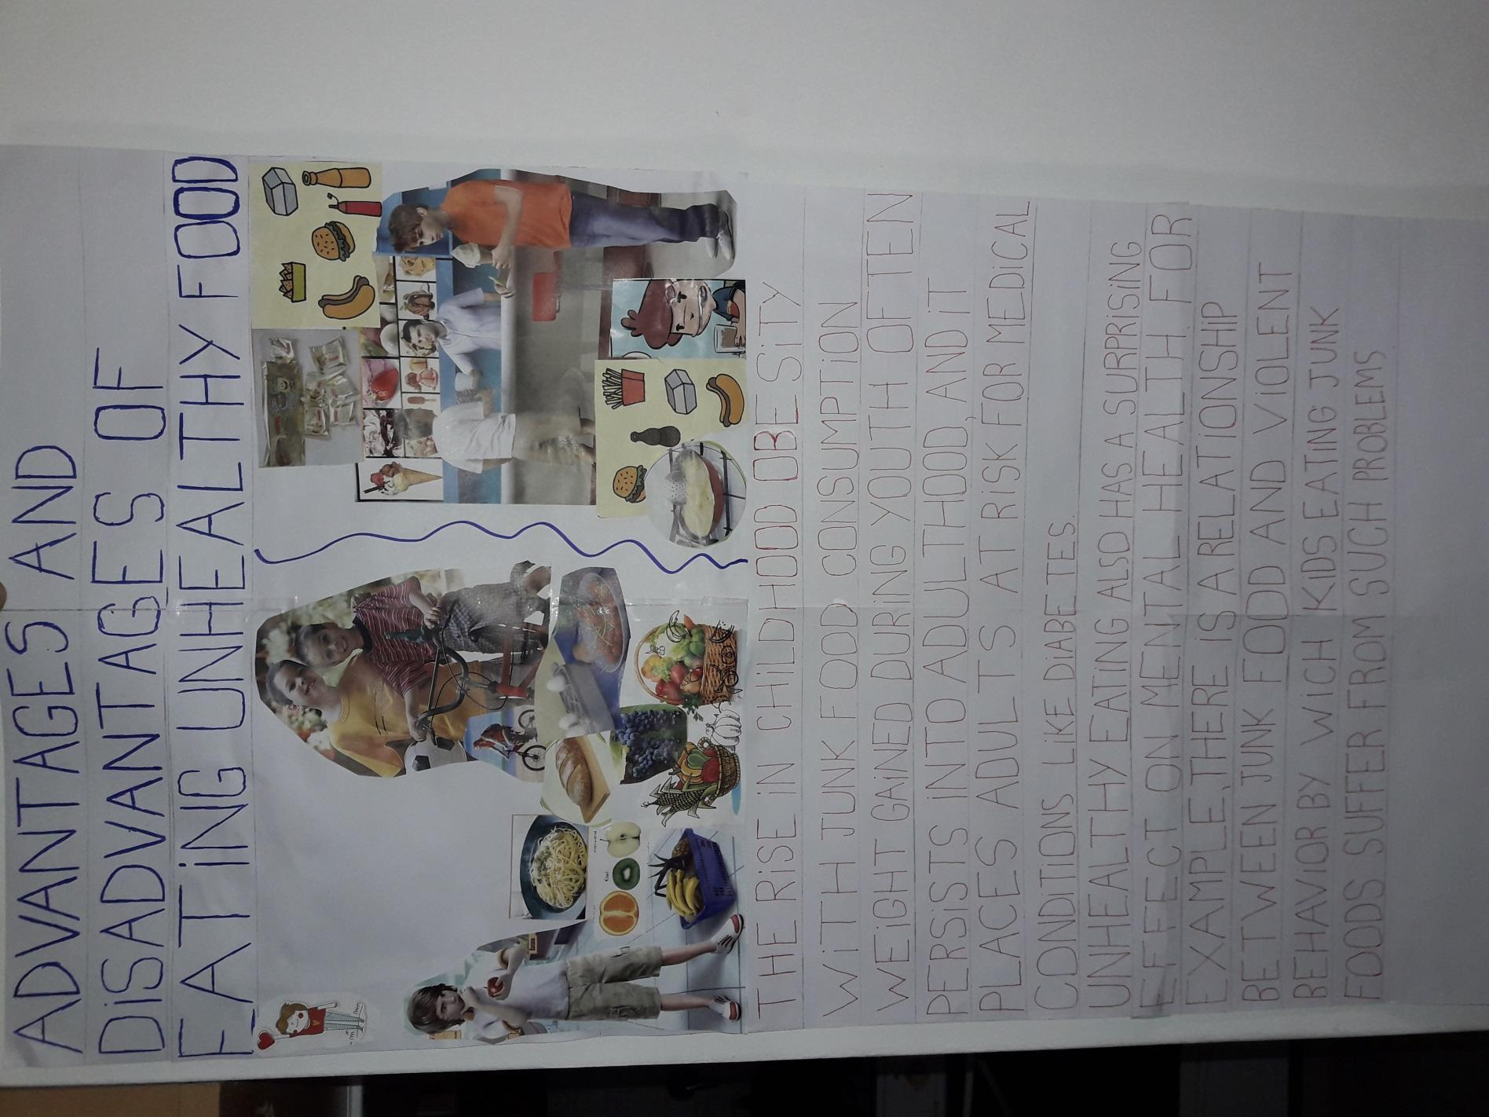

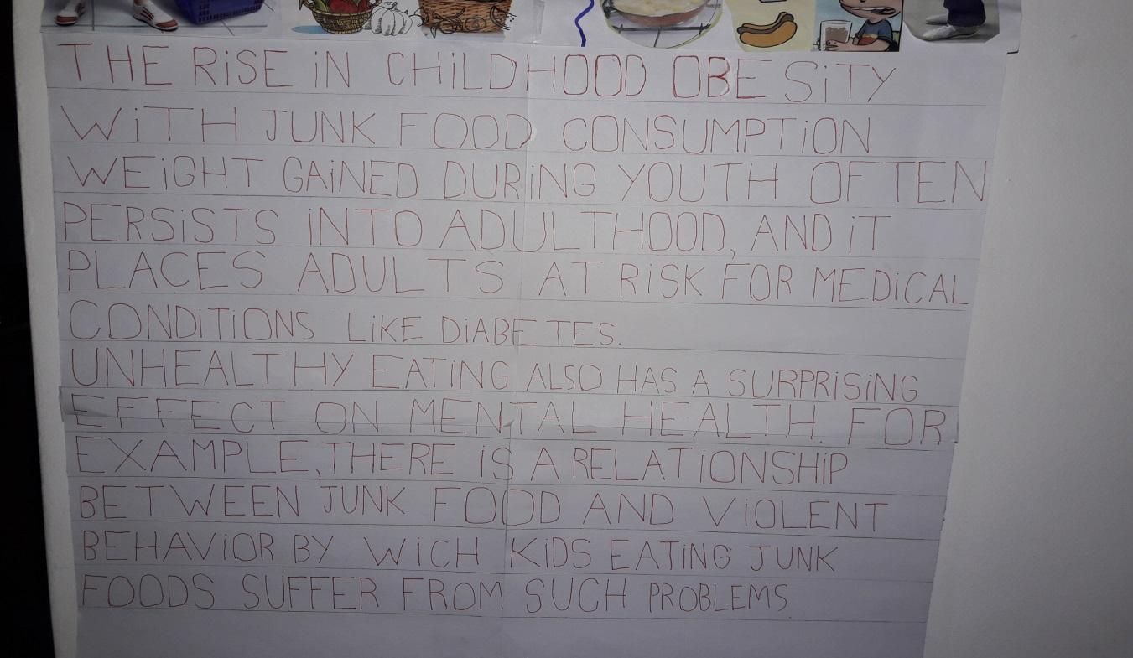

**you don't need to eat less, you just need to eat well**